Project 5: Probability and Expected Value

Name:_________________________

Rationale:
Understanding the connection between probability and expected value is an important skill to have. There are many times that knowing the expected costs can be beneficial to you: knowing whether to take a warranty on the purchase of a new television, whether the insurance policy you are taking is priced correctly, or even predicting how much money you are likely to spend when you go out to eat with your friends on the weekend can all use expected value to help you make decisions.

Instructions:
In this assignment, you will analyze the results of a carnival game for a school fund raiser. You should use Probability and the principles of Expected Value to analyze the game and answer the following questions. You should determine the theoretical probability of the game first. Then, simulate the game to determine your own experimental probability. Once both probabilities have been found, you will discuss implications on the similarity of the two probabilities with the class. You will determine the expected value of the game from the school's perspective. You will then make a rational recommendation to the school about the game.

The Game: Making Purple
To raise money, a local school holds an annual school carnival. They invite students, their families, and their local community to the carnival and provide games and activities. One of the most popular games is a game called Making Purple. A player spins the pointer of each spinner below once. Getting a red on one spinner and blue on the other spinner wins, because red and blue together make purple.

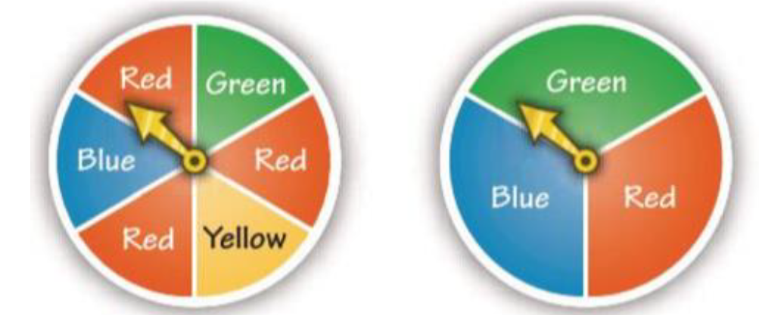
Theoretical Probability
Theoretical probability is the probability based on analyzing the results and calculating the probabilities. It relies on counting and analysis and the correct use of combining probabilities. This section will guide you through analyzing the Making Purple game to find the theoretical probability that any given spin will result in making purple.
Step 1: Finding individual probabilities
For simple events, you can find the probability by counting the number of times an event occurs and dividing it by the total number of occurrences.
First, find the individual probabilities for the first spinner.
How many outcomes are possible on the first spinner?
What is the probability of spinning red on the first spinner?
What is the probability of spinning blue on the first spinner?
What is the probability of spinning green on the first spinner?
What is the probability of spinning yellow on the first spinner?
How can you be sure that you've found all of the probabilities correctly?
Now, find the individual probabilities for the second spinner.
How many outcomes are possible on the second spinner?
What is the probability of spinning red on the second spinner?
What is the probability of spinning blue on the second spinner?
What is the probability of spinning green on the second spinner?
How can you be sure that you've found all of the probabilities correctly?
Step 2: Finding combined probabilities
When combining independent events that are mutually independent (the results of one don't affect the other and vice versa), then you multiply the corresponding probabilities.
What is the probability of spinning red on the first spinner and blue on the second spinner?
What is the probability of spinning blue on the first spinner and red on the second spinner?
When combining results from the same experiment or game, add the results of the independent outcomes.
What is the combined probability of Making Purple?
Step 3: Finding the complement
A complement is the opposite outcome of what is listed. To find the complement, remember that the sum of an event and its complement is 1.
What is the probability of not Making Purple?
Experimental Probability
Experimental probability is based on experience. Generally, you need to perform the experiment many times in order for it to represent the real probability. To calculate the experimental probability, perform the experiment (or play the game) several times, recording whether each game was successful or not. Then, divide the number of successes by the total number of experiments, and you'll have your experimental probability.
Play the Making Purple game several times (around one hundred times). Based on your results, what is the experimental probability that a player will "Make Purple" on a given spin?
To play the game, you can either make your own spinner, as shown above, or you can simulate the spinner using dice or a random number generator, such as Excel's RANDBETWEEN function. As an example, you could assign the numbers 1, 3, and 5 to red, 2 to blue, 4 to yellow, and 6 to green for the first spinner and the numbers 1 and 2 to blue, 3 and 4 to green, and 5 and 6 to red. Be sure to record how you simulated your responses when showing your work for this part.
Comparing Theoretical and Experimental Probabilities
You will need to gather the results from 5 peers in order to complete this section. Go to the DISCUSS 5a: Making Purple Trials Results. (1) Post your results and (2) Record the results from 5 peers below.
1)
2)
3)
4)
5)
Combine the results, including yours (total number of successes divided by total number of experiments). In this part of the assignment, you must compare and contrast your results from your experiments with the theoretical probability calculated above.
Write the TOTAL RESULT here. (total number of successes divided by total number of experiments.)

Questions:
Compare your individual experimental and the results of each peer with the theoretical results. How similar is each experiment to what the theoretical probability was?
Compare the group's combined results to the theoretical probability. Was it closer or further than the individual results? Why do you think this is?
Why do the results from the individual trials differ so much from each other and from the theoretical results?
Under which circumstances would you use theoretical probability?
Under which circumstances would you use experimental probabilities?
Which is better, theoretical or experimental probabilities? Why?
Expected Value
Expected value multiplies the value or worth of each outcome by the probability of that outcome occurring. Where possible, you should use theoretical probabilities to calculate the expected value. That is the case with this problem. It is important to make sure you look at the value from the appropriate point of view.
The cost to play Making Purple is $2. A winner gets $6 total for a winning game of Making Purple. Answer the following questions. Where applicable, show your work.
What is the expected value of a single game of Making Purple for the school?
Suppose that 36 people play the game. How many of these 36 players do you expect will win a prize?
How much money do you expect the school to pay out in prizes if they only play 36 games?
How much profit or loss do you expect the school to make from 36 games?
Should the school continue to include Making Purple in their school carnival? Justify your answer in at least two sentences, using numbers appropriately.

Discussion Questions
After you complete the questions above, consider the following discussions. You will post your answers to these questions on the appropriate discussion boards for this project.
- What was your calculated expected value?
- In at least two sentences, what does expected value mean?
- A certain company sells an insurance policy on their phones. The policies sell for $129 and have an expected value of $45 each. This means that for every policy they sell, they expect to make $45. Now that you have an idea about what expected value means, what information does the expected value of the policy give you?
- What have you learned about probability and expected value as a result of this assignment?

